Software Requirements Specification/Project Plan

March 15, 2017

Periodic Table Program

Joshua Filer
Nick Martin
Vy Dinh
Jordan Geddes

Table of Contents

Table of Contents
Table of Contents i
1.0. Introduction 1
1.1. Purpose 1
1.2. Scope of Project 1
1.3. Definitions, acronyms, and abbreviations 2
1.4. References 3
1.5. Overview of Document 3
2.0. Overall Description 3
2.1 Product Perspective 3
2.2 Functional Requirements Specification 4
2.2.1 Element selection 4
2.2.2 Exiting the Program 4
2.2.3 Closing Element Display 4
2.3 User Characteristics 5
2.4 Constraints 5
2.5Assumptions and Dependencies 5-6
3.0. Specific Requirements 6
3.1 External Interface Requirements 6
3.1.1 User Interface/Buttons 6
3.1.2 External Interfaces 7
3.2 Data Flow 8
3.3 Classes/Objects 9
3.3.1 Element 9
3.3.2 TableGUI 10
3.3.4 Xform 11
3.3.5 Periodic Table 12
3.4 Design Constraints 12
4.0 Schedule of Project Plan/Outline of Roles/Requirements 13
4.1 System Requirements 15
4.2 Expected Scenarios 16
Appendix 17
Appendix A: Classes/Objects Diagram 18
Appendix B: Level 0 DFD(Architectural Context Diagram) 19
Appendix C: Level 1 DFD 20
Appendix D: Use Case Scenarios 21
Appendix E: High Level Flow chart(as Seen in section 3.2) 23
Appendix F: State Diagram 24

1.0. Introduction

1.1. Purpose
The purpose of this document is to present a detailed description of an interactive three dimensional periodic table to allow students, teachers, and professors to explore a 3D shaped atomic nucleus of each different element.

1.2. Scope of Project
The software name for this product will be named, “Martin, Filer, Dinh, and Geddes’s 3D Periodic Table”. This software system will be an application that will store all element and atomic information into a database which will convert and display all information into a 3-dimensional periodic table. Since most students and professors would look up and research basic information of elements either from an online chemistry textbook or online search engine, this program will be designed to be a perfect substitute to allow easier access for students and professors to utilize the same level of research as online sources or books would do. Of course, the software system will be installed upon user request and would become a requirement for most biology and chemistry classes for high schools and colleges alike.

This program is intended to be used by high schools and colleges such as University of Maryland with chemistry and biology classes at different levels, and it will take all inputs via mouse clicks from students and professors to display the proper elements and nucleus models. Because the periodic table model is allowed to be used by students and professors alike, there would be no login or administrative features as it will allow for equal use, without any security issues. Not only will this interactive periodic table be used for just colleges and schools in America, but for various schools and universities worldwide.

1.3. Definitions, acronyms, and abbreviations
Term | Definition
Periodic Table | A table of the chemical elements arranged in order of atomic number, usually in rows, so that elements with similar atomic structure (and hence similar chemical properties) appear in vertical columns.
Student | One who studies at a high school or college and utilizes all search engines and programs required for a class.
Teacher/Professor | A teacher on a certain subject at a high school or college specialized to teach a variety of students on a topic/subject.
Element | A GUI representation of an element name with all specified information of that element.
Model | A 3D model representation of all protons, neutrons, and electrons of an element’s nucleus.
Table GUI | A graphical user interface of the periodic table showing all of the different elements and names
Array List | The list storing all element names and information read from a file.
IEEE | Institute of Electrical and Electronics Engineers
User | Student, Teacher, or Professor.
Symbol | Letter Symbol of element
X and Y coordinate | Coordinates of vertical and horizontal dimensions of an element in the table
Atomic Number | Atomic number of element
Mass Number | Mass number of an element

1.4. References
IEEE. IEEE Std 830-1998 IEEE Recommended Practice for Software Requirements Specifications. IEEE Computer Society, 1998.

Pradeepa, P. (2015). “Software requirements Specification.” LinkedIn Corporation. Retrieved from: http://www.slideshare.net/PreshanPradeepa/software-requirements-document

Gudavalli, K. (2013). “Software requirements specification.” LinkedIn Corporation. Retrieved from: http://www.slideshare.net/KrishnasaiGudavalli/software-requirements-specification-17173967

(2012). “JavaFX 2.2 System Requirements.” Oracle. Retrieved from http://docs.oracle.com/javafx/2/system_requirements_2-2/jfxpub-system_requirements_2-2.htm

Geddes, J. (2017). “Jgeddes101/periodic-table.” GitHub. Retrieved from: https://github.com/jgeddes101/periodic-table

1.5. Overview of Document
The following chapters will provide the overall functionality of how this Periodic table program will operate for students and professors alike. The upcoming chapter will describe the general factors and provide background on the main functions that will be used for the system. All major technical functions will be described in detail in the Third chapter of this document.

- The third chapter, Requirements Specification section, of this document is written primarily for the developers and describes in technical terms the details of the functionality of the product.

- Following these chapters, there will be an appendix displaying the class diagram, low level flowchart, high level flowchart, and State-diagram to further explain the processes of the periodic table.

- Following the appendix, there will be a high level schedule of how the program will operate and what technologies would setup and store all aspects of the program.

2.0. Overall Description

2.1 Product Perspective
The Periodic table program is an independent, self-contained system with no support from websites, or larger enterprises. Because of its independence and isolation from other enterprises, the usability of the application will be very efficient for the user along with the speed of every process being efficient as it only functions from only Java applications, and not any SQL or other database credentials, which may slow the processes down greatly.
2.1.1 User Interfaces
- Table view: A Window that displays a periodic table grid and to allow a user to select an element to displays its credentials and 3D model.

- Model view: A window that displays the actual 3D model of the nucleus of a selected element and allows a user to scroll around the model to find all of its protons, neutrons, and electrons.

- Element information: A window that pops up after selecting an element to show off the atomic number, mass number, mole, and any other important element specifications.

2.2 Functional Requirements Specification
The functionality of the Periodic table can be broken into the following steps:

2.2.1 Element selection

Description: The user selects an element from the table view to view the element information and 3D model of the desired element.

Reference High Level Flow chart in Section 3.2: Data Flow

2.2.2 Exiting the Program

Description: Once the user is done with the periodic table program, the user will hit the close button, terminating the program.

Reference High Level Flow chart in Section 3.2: Data Flow

2.2.3 Closing element display

Description: The user may be able to exit an element window if he/she feels that the element has been viewed enough, by pressing the close button in the information display. This would return the program to the main table display until the close button has been pressed. The same works for the 3D model and will return the user to the information display, followed by clicking the close to go back to the periodic table menu.

Reference High Level Flow chart in Section 3.2: Data Flow

2.3 User Characteristics
The users for the Periodic Table are the students and professors studying the elements and periodic table. They are accountable towards what element to select and study off of, and to view the atomic nucleus of each element from different angles at their discretion.
The students and professors are expected to know where each element is located on the periodic table, and briefly have an understanding of the differences between protons, electrons, and neutrons of an atom prior to figuring out how each element is displayed through a 3D model. They are also expected to know all the element’s figures and numbers prior to viewing all windows of element specifications, in which most cases the element specs may appear confusing to the users. Basically, scientific knowledge of the elements and periodic table is expected prior to using this interactive periodic table system.
A student is anyone of high school age to college age, who is expected to have some knowledge of periodic tables and element specs. A student must even know how to utilize computer programs and use the computer mouse effectively in order to navigate and utilize the computer program.
Professors are teachers of adult age and are expected to have full knowledge of the elements and periodic table to help teach students how to read periodic tables and element specs. Of course, the professor is expected to know how to use computers and the computer mouse effectively before attempting to use the periodic table program.

2.4 Constraints
- The Periodic table is only active with a computer that utilizes Java technology.

- The Periodic table requires mass memory to operate. A computer that has insufficient memory with this program installed would result in low performance of the program.

- The Periodic table program is only used on computers only, and not accessible for mobile and tablet platforms. Any Windows, Mac, or any third party computer would work to run this program, but it must have Java APIs and virtual machines installed in order for the program to work properly.

- All Periodic table elements must be stored in Array Lists and Array elements in order to provide maximum performance.

- Any User may access the Periodic table from any computer within a school or at a home computer as long as there is an Internet connection is present, and the program is downloaded from the site in which it was produced from.

2.5 Assumptions and dependencies
The following assumptions and dependencies are made for the Periodic Table program to operate properly:
- Oracle Java API and Java virtual machines are installed in the system to have the program operate properly.

- The institution or school, or home computer has all Java virtual machines, APIs, and other system requirements fully up to date as stated in section 4.1: Requirements.

- There is a work station or comfortable station available to access the computer and run this program properly.

- The computer system provides and ample amount of power and memory in order for the program to run efficiently and with fast speed for the users to have the best usage possible compared to any other program.

3.0. Specific Requirements

3.1 External Interface Requirements
The following are the requirements specific to the interaction between the software system, the users, and other components of the system:

    - User Interfaces/Buttons
- Table view: Includes the grid view of a periodic table. All windows to include the table menu will be displayed as a Graphical User Interface (GUI) utilizing a combination of grid panes and buttons from the JavaFx API. These buttons will have assigned handlers to determine the actions of clicking on them.

Refer to the Create Table Flow Chart in the Appendix section: Data Flow of Program.

- Element data: Each element is constructed as needed when it is selected on the GUI. This constructor passes in the relevant information for display and use in the methods which generate the 3D model.

- Model view: Shows a display for the user to display the 3D model of the atom of a nucleus. Because of the 3D design of the nucleus and the effects of rotating around the 3D model of the nucleus, a camera and a mouse handler must be included to allow the user to click and rotate around the nucleus model. All particles such as electrons, protons, and neutrons of the model should be coded in certain coordinates to carefully model off of the nucleus with all particles placed in the correct positions as specified how each atom model looks in a traditional Bohr’s Model. Any methods such as hard-coding or looping for correct positions should be considered when creating all atomic particles within the 3D model.

- Information View: Shows after a user selects an element from the table and displays all of the specifications and numbers of the element selected. The view should incorporate not only a GUI window, but also include JavaFx buttons to hit “Display Model” to enter into the 3D model, and to also allow the user to close the window at his/her discretion. All specifications from a certain element must come from the array database and match the proper element selected. If else statements and switch statements should be used to help with selecting the proper specifications for the desired element selected.

- Close Buttons: X buttons that the users press to close out both an element window and of course the program. The close buttons should display and the program should follow with closing the window and returning back to the main table menu. In the table menu, if the close button is pressed, the program should cancel out a window, and the program if it’s in the main periodic table menu.

- Display Model Button: JavaFx buttons that are incorporated in the Information menu that would allow the user to close out the Information menu and open into the 3D model of the specified element. In any Information page of an element, the button should automatically close the Specifications view and automatically open the Model view for the viewers to see the desired element nucleus he/she has selected.

3.1.2 External Interfaces
- Mouse: Used by the user and the professor to scroll and select a desired element from the periodic table. The mouse will be a crucial component especially with the scrolling components involved with the Model View. Any mouse or scrolling pad on laptop computers will greatly qualify in making the rotator listeners function properly.

- Keyboard Commands: Used by the users help zoom in and out when viewing the model of a certain element. This would greatly apply to lab top users who don’t have a connected mouse and have to utilize a mouse pad which makes it difficult to zoom in and out. These commands should apply to all computers to include lab top systems.

3.2 Data Flow
Most of the methods associated with the periodic table such as Create Table, Display Element, and Display Model will be utilized to set up the entire periodic table in the correct order as most periodic tables are set utilizing loops and arrays to provide all of the correct information in order and display it to the user. Button listeners will be utilized to determine if the close button is pressed on any of the views in order to terminate and end the program. If any Close button is pressed, any said view will terminate. If the close button is pressed in the main table display, the program will terminate. Please refer to the Flow chart document below to see what methods will be used to perform said functions. Refer to Appendix C for more detail on Data flow.

High Level Flow Chart of Data
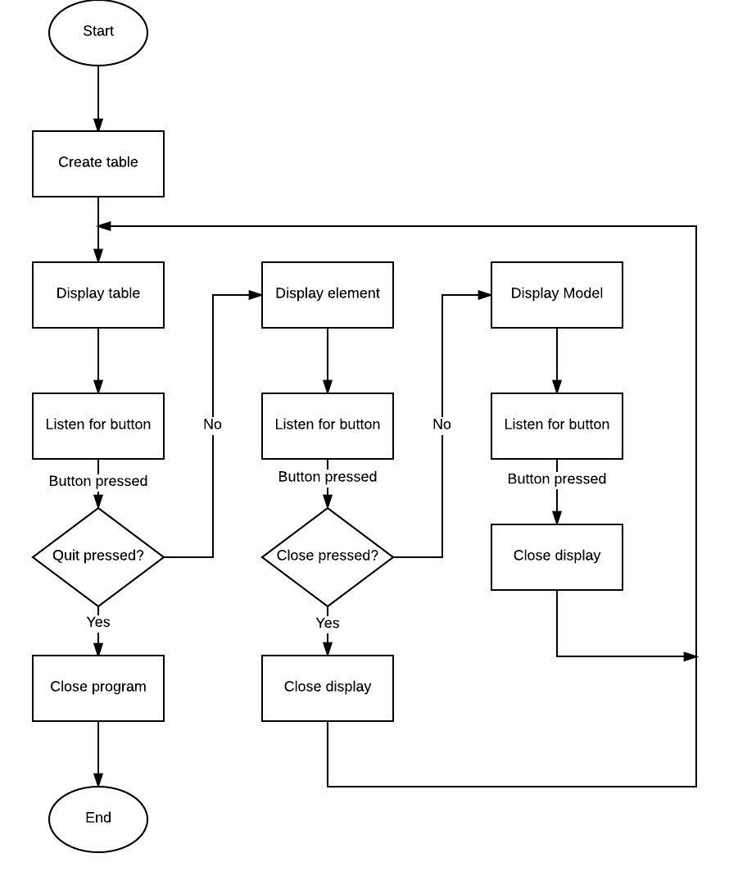

3.3 Classes/Objects
The following represents a decomposition of attributes and methods associated with each class of the Periodic table program. A classes/Objects diagram summarizing the relationships between classes can be seen in Appendix A.

3.3.1 Element
This object represents information of an element. The element comprises of 7 attributes.

- Name: String that represents the name of an element.
- Phase: String that represents the phase the element is in such as a solid, liquid, or gas.
- Meltpoint: Double number that represents the element’s temperature at melting point.
- Boil Point: Double number that represents the element’s temperature at boiling point.
- Heat Fusion: Double number that represents the element’s temperature of heat fusion.
- Heat Vapor: Double number that represents the element’s temperature when it goes through evaporation when in contact to heat.
- Atomic Number: An integer representing the atomic number of an element.

3.3.2 Table GUI
This object is the builder of all GUI table views to include the main periodic table menu, the element information view, and all buttons/handlers associated with selecting elements and displaying models. It has 7 attributes both inherited and non-inherited along with 4 methods for the buttons and keys.

- Element(class): Inherited constructor that contains all information regarding an element in order to be displayed in the element information view.
- Gridpane(class): Inherited constructor that helps with creating all grid panes necessary for the periodic table and element information menus.
- PhaseTxt: GUI text attribute that represents the label of an element’s current phase.
- MeltTxt: GUI text attribute that represents the label of an element’s melting point.
- BoilTxt: GUI text attribute that represents the label of an element’s boiling point.
- FusionTxt: GUI text attribute that represents the label of an element’s point of Heat Fusion
- VaporTxt: GUI text attribute that represents the label of an element’s point of evaporation.
- myHandler(): This method is used to determine actions to perform when a button is pressed.
* It will build the second window and populate it with information based on what button was selected. It does this by instantiating the object of type Element. This information is used by the various fields in the popup window to display the information about the selected element.

- modelHandler(): Method that handles in displaying the Model display of each element. When the display model button is pressed, this handler initiates with showing the model display.
- addButton(): This method Constructs each button then places in the correct position in the GridPane to form the periodic table.
- addKey(): This method Constructs and formats each portion of the key, then places in correct location in the GridPane.

3.3.3 Model
This object represents the 3D model view of each element and creates all the 3D models of each element. Note: all camera positions and angles will be in a fixed position. Refer to Appendix A: Classes/Objects Diagram for further reference of final fixed positions. The model class has up to 16 attributes and 6 methods.

- Group root(class): Inherited constructor that is a group of all model components and methods within the 3D model.
- AxisGroup(class): Xform class containing components from an Xform group to help with building the 3D model at different axis areas of the model.
- AtomGroup(class): Xform class building a group to hold all model components of each Atom.
- World(class): Xform class utilizing the entire landscape of the model view.
- Camera(class): Perspective Camera class that makes up the main viewing camera of the model.
- CameraXform(class): Xform camera class making up the first viewpoint of the camera for the model.
- CameraXform2(class): Xform camera class making up the second viewpoint of the camera for the model.
- CameraXform3(class): Xform camera class making up the third viewpoint of the camera for the model.
- AtomXform(class): Xform class representing the shape/form of each atom for the model.
- MousePosX: Double number representing the mouse’s position on the x axis of the model.
- MousePosY: Double number representing the mouse’s position on the y axis of the model.
- MouseOldX: Double number representing the mouse’s initial position on the x axis of the model.
- MouseOldY: Double number representing the mouse’s initial position on the y axis of the model.
- MouseDeltaX: Double number representing the mouse’s delta position on the x axis of the model.

- MouseDeltaY: Double number representing the mouse’s delta position on the y axis of the model.
- NucleonRadius: Integer number representing the radius of a nucleus for each atom in the model.
- displayModel(): This method creates the window to display the 3D model based off each element.
- buildCamera(): Method that creates the camera for the 3D model.
- handleMouse(): This method and listener handles all mouse input, output, and scrolling as done by the user when interacting with the model view.
- buildModel(): The primary method to begin the model creation. This method calls the buildAtom method.
- buildAtom(): This method builds the electrons and places them in the correct orbitals. It then calls the method createNucleus to handle the nucleus construction.
- createNucleus():This method contains the array of positions for each nucleon. These values are passed to the addNucleus method to construct the nucleus and add it to the window.
- addNucleus():This method uses the positions from the createNucleus method to place each nucleon in the correct position. It then assigns the material based on an even/odd basis.

3.3.4 Xform
This is a helper class with all Xform and 3D aspects toward the model class. All methods and attributes point out all translations, rotations, scaling, and debugging within the 3D model because it utilizes 3D tools. This class takes up to 7 attributes and 18 methods.

- T(class): Translation class that to assist with translation of the 3D model in the model class. Note: translation classes are placed at different positions of the 3D model. Each letter class represents a different position throughout the 3D model.
- P(class): Translation class that to assist with translation of the 3D model in the model class.
- Ip(class): Translation class that to assist with translation of the 3D model in the model class.
- Rx(class): Rotator class that sets points of rotation throughout the 3D model in the model class. Note: rotation classes are placed at different positions of the 3D model.
- Ry(class): Rotator class that sets points of rotation throughout the 3D model in the model class.
- Rz(class): Rotator class that sets points of rotation throughout the 3D model in the model class.
- S(class): Scaling class that helps to set up the scale of the 3D model in the model class.
- setTranslate(): Method that sets up all translation points for the 3D model. Note: there are two of these methods which set translation points at different positions: x, y, and z.
- setTx(): Method that sets up translation point x in the 3D model.
- setTy(): Method that sets up translation point y in the 3D model.
- setTz(): Method that sets up translation point z in the 3D model.
- setRotate(): Method that sets up all rotation points for the 3D model.
- setRotatex(): Method that sets up rotation point x in the 3D model.
- setRotatey(): Method that sets up rotation point y in the 3D model.
- setRotatez(): Method that sets up rotation point z in the 3D model.
- setRy(): 2nd Rotation method that sets up rotation point y in the 3D model.
- setRz(): 2nd Rotation method that sets up rotation point z in the 3D model.
- setScale(): Method that sets up the scale of the 3D model at different points: x, y, and z.
- setSx(): Method that sets up the scale at point x in the 3D model.
- setSy(): Method that sets up the scale at point y in the 3D model.
- setSz(): Method that sets up the scale at point z in the 3D model.
- setPivot(): Method that sets up pivoting positions at points x, y, and z in the 3D model.
- Reset(): Method that resets all point positions to 0 when the model is no longer needed to be displayed.
- ResetTSP(): Method that resets all Translation positions to 0 when the model is no longer needed to be displayed.
- Debug(): Method that debugs any discrepancies at all position points within the model.

3.3.5 Periodic Table
This is the main class that creates the periodic table program by calling the table GUI class and setting up the entire scene for the user to gain access to the program. It contains 3 attributes and one main method.

- Grid(class): Gridpane class that creates the main grid to be used for all displays.
- Gui(class): TableGUI class that creates all the displays associated for the periodic table program.
- Scene(class): Scene class that creates the whole scene for the periodic table program.
- Main(): Main method to start the entire program.

3.4 Design Constraints
There are no known design constraints for this system based on the requirements.

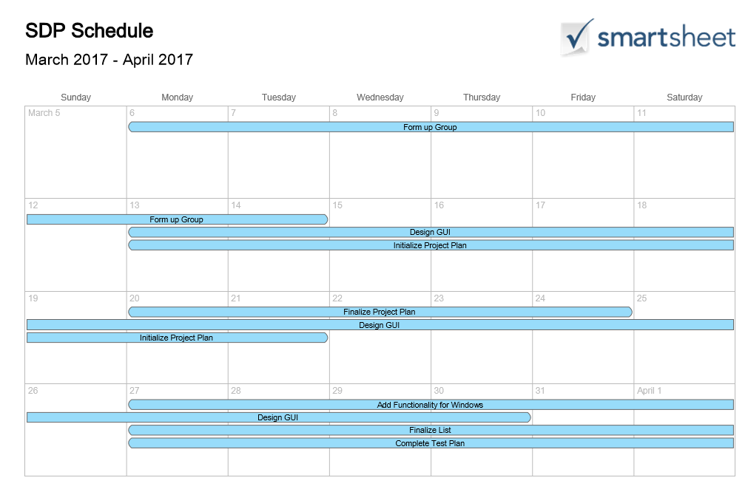
4.0 Schedule of Project Plan/Outline of Roles/Requirements:

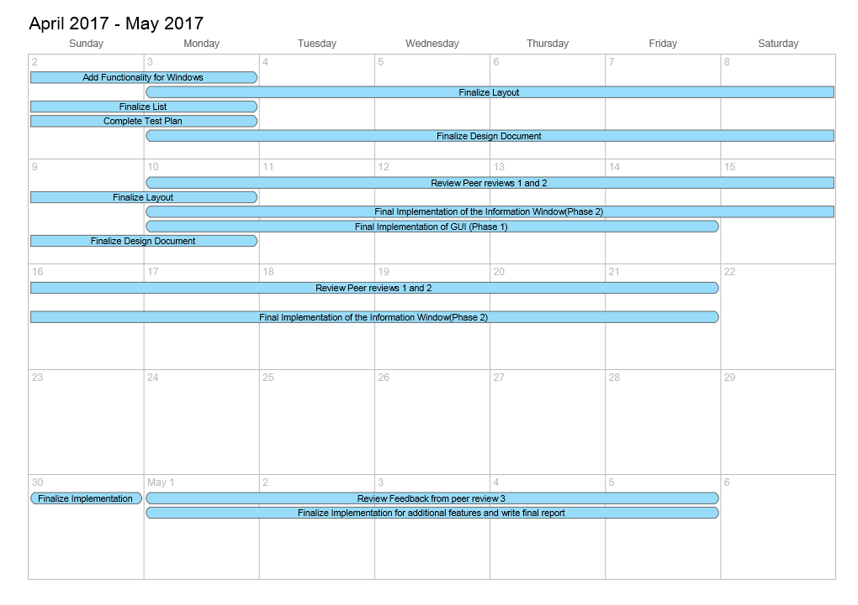

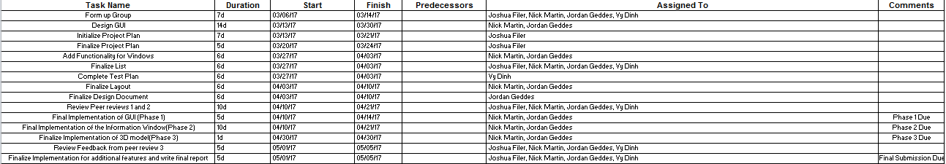

- This schedule depicts what should be accomplished each week. Blue represents mandatory requirements and the durations of how long each phase of the plan of the project should take. Each date at the top represents the end of each week and “Due” represents when a certain portion of the project should be complete.

- Most Important phases of the project should take about 2 weeks, just to allow for the second week to make any changes or final edits.

- All Programming codes and documentations should be shared via email and Github.com. For storage of all code must be done in GitHub.com to allow developers to look back, analyze, and edit code when necessary to make any corrections or revisions. The same goes for this document followed by all other important documentation for this project.

- For further information contact:

  - Joshua Filer: joshua.filer@yahoo.com
    - Roles: Project Plan/User Guide and Test Plan/Project Design/Final Submission: Lead in Documentation
  - Nick Martin: nickmmartin@yahoo.com
    - Roles: Phase 1 Source: GUI/Phase 2 Source: Popup Windows/Phase 3 Source: 3D Model/Final Submission: Lead Coder
  - Vy Dinh: vydinh09@gmail.com
    - Roles: Test Plan and User Guide/Phase 1 Source: GUI/Phase 2 Source: Popup Windows/Phase 3 Source: 3D Model/Final Submission: Second in Documentation
  - Jordan Geddes: jgeddes101@gmail.com
    - Project Design/Phase 1 Source: GUI/Phase 2 Source: Popup Windows/Phase 3 Source: 3D Model/Final Submission: Second Coder
  - All Developers would also partake in all Peer 1, Peer 2, and Peer 3 reviews.

4.1 Requirements

The following section describes the system requirements for this project:

Java Platform
For the Windows platform, use JavaFX 2.2 with a minimum of Java SE 6 Update 33 or Java SE 7 Update 6 installed on your system.
For Linux platform, use JDK 6 update 26 or later.
For Mac OS X, use Java SE 7 Update 6 for Mac OS X. JavaFX 2.2 has not been formally tested with Apple's Java SE 6 implementation for Mac OS and support is offered only when used with Java SE 7 Update 6 or later.

Other Software
JavaFX 2.2 for Linux requires gtk2 2.18+.

Graphics Support
For JavaFX applications to take advantage of the new hardware acceleration pipeline provided by JavaFX, your system must feature one of a wide range of GPUs currently available in the market. Table 1 lists the graphics cards that have been tested with JavaFX. If your system does not support hardware acceleration, then JavaFX uses the Java2D software pipeline.
Table 1 Graphics Cards Support
Graphics Card | Supported Graphics Processing Units (GPUs)
NVIDIA | Mobile GPUs: GeForce 8M and 100M series or higher, NVS 2100M series or higher, and Mobility Quadro FX 300M series or higher  Desktop GPUs: GeForce 8 and 100 series or higher  Workstation GPUs: Quadro FX 300 series or higher
ATI | Mobile GPUs: Mobility Radeon HD 3000, 4000, and 5000 series  Desktop GPUs: Radeon HD 2400, 3000, 4000, 5000, and 6000 series
Intel | Mobile GPUs: GMA 4500MHD and GMA HD  Desktop GPUs: GMA 4500 and GMA HD
For Mac OS, JavaFX supports graphic hardware acceleration on any Mac OS X system that is Lion or later.
On Linux platform, 3D features are supported for Nvidia cards (proprietary drivers only).
To avoid rendering issues on Windows platform, upgrade the ATI driver to Catalyst 11.09 or later.

4.2 Expected Scenarios
This section describes what is to be expected from testing the periodic table program. Note, the results may vary when it comes to actual testing.
- User loads the program and is brought to the main screen showing the periodic table with color-coded sections based on the classifications of the elements. The table will be constructed of buttons which display the atomic symbol and atomic weight of the element.
- The user will select the element they wish to know more about. A window will open displaying the name, atomic weight, density, atomic number, phase at standard temperature and pressure, melting point (in kelvin), boiling point (in kelvin), heat of fusion and vaporization (in kJ/mol).
- This window will contain a button which the user can click to bring up a 3-D model of the atomic structure based on the Bohr's Model. This model can be rotated, panned, and zoomed. It will contain the particles for the nucleus and the orbits of the electrons, along with the corresponding electronic configuration.
- All windows can be closed using the x in the upper right corner. The program can be terminated in the same fashion.
- The program will utilize JavaFx components and the system running it must meet the requirements for JavaFx.

Appendix

Appendix A: Classes/Objects Diagram

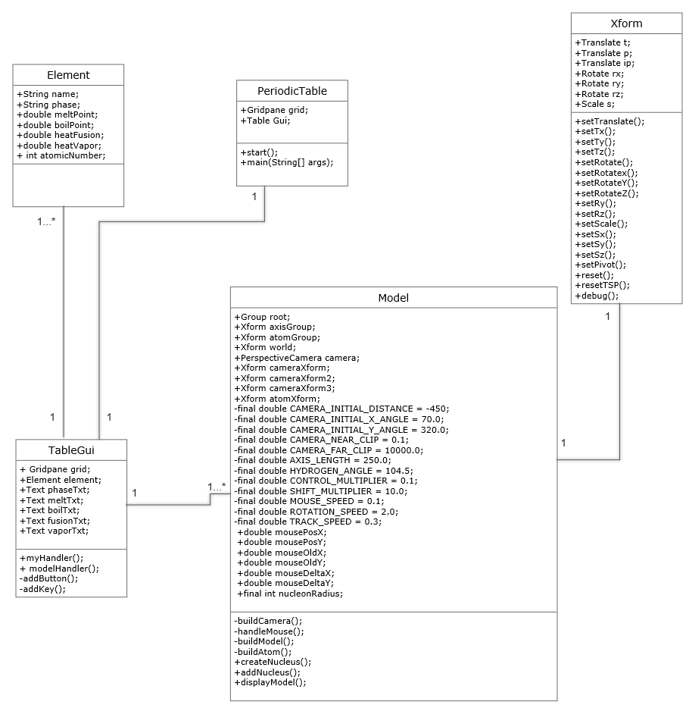

Appendix B: Level 0 DFD(Architectural Context Diagram):
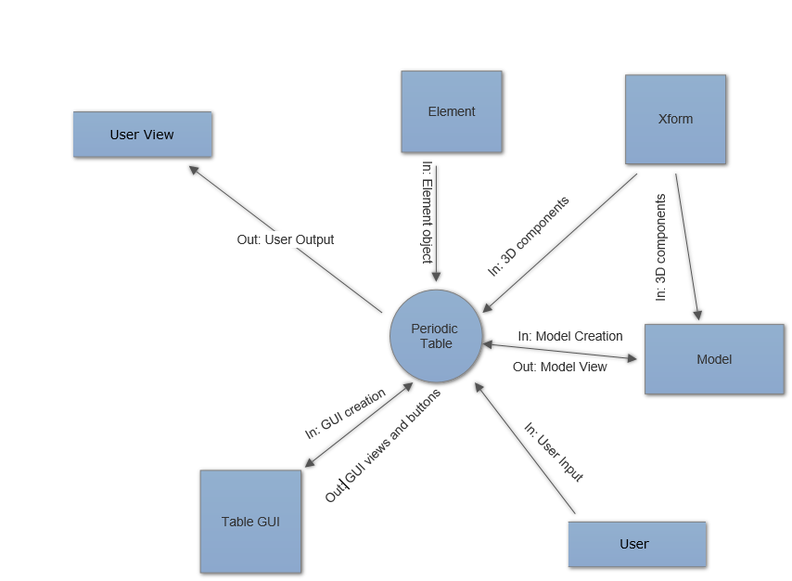

Appendix C: Level 1 DFD
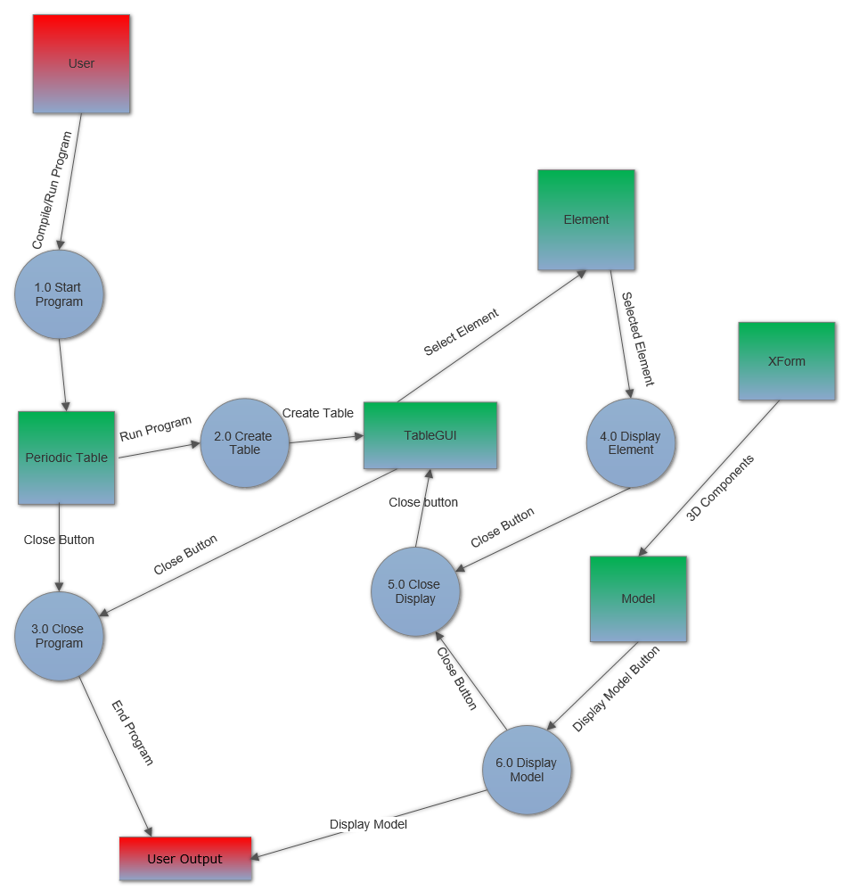

Appendix D: Use Case Scenarios

Use Case: Student searches for Oxygen element
Student accesses the periodic table program and searches for the element of Oxygen to record the atomic number and state of the element.

Pre-Condition: The application should be running and accessible to the student.

Post-Condition: The system should display the element page of Oxygen showing the atomic number, heat fusion, boiling point, melting point, mass, state, and heat of vaporization.

Actor Profile: Student is studying online for a chemistry exam, which is coming soon and he doesn’t have time to search through his text book for the answers.

Sequence of Events:

- Student loads up Periodic table program.
- Student navigates to the Oxygen button on the periodic table
- Student presses the Oxygen button
- Element page displays
- Student records the atomic number and state of the element.

Scenarios:

User Scenario 1: Finding the Element
- User navigates to oxygen
- Oxygen button is pressed

User Scenario 2: Element Information accessed
- Oxygen element display appears
- Atomic number and state of element displays
- Personal note of Atomic number and state are made by user on notepad
- User hits the close button bringing back the main menu of periodic table program

Use Case: Teacher displays a 3D model of the element Xenon
A Chemistry teacher displays an active 3D model of the element Xenon to his students from the computer connected to a projection screen.

Pre-Condition: The application should be running with the element display active and the model display button is accessible to the teacher.

Post-Condition: The application should be ready to show the 3D model.

Actor Profile: Teacher is instructing students on the element of Xenon and is ready to show the students the active 3D model of Xenon.

Sequence of Events:
- The teacher loads the Xenon element display and explains all specs of the element.
- The Teacher clicks the Display Model button.
- The 3D model of Xenon displays
- The teacher scrolls around the element, zooms in and points at certain parts of the model.
- The teacher explains the element and hits the close button to exit the 3D model and goes back to the element display.
Scenarios:

User Scenario 1: Accessing the Model
- The user selects the Display Model button in the element page
- The 3D model page of the Atom Xenon displays

User Scenario 2: Using the Model
- The user scrolls around the 3D model to rotate the model around at different points
- The user zooms in to the nucleus of the Atom model to display all protons and neutrons at a closer view.
- The user then closes the display via the close button and the element display is brought back on view.

Use Case: Student cycles through the whole program from open to close
A student tests a newly installed periodic table program from opening to close

Pre-Condition: The application should be running and be accessible to the student.

Post Condition: The application should have successfully shown a desired element page, 3D model, and closes successfully upon user input.

Actor Profile: The student is trying out his new fully installed program and tries out all the different features.

Sequence of Events:
- The student navigates to the first element of the table.
- The student presses the element button.
- The student views the element page.
- The student presses the Display Model button.
- The student views and scrolls around the 3D model.
- The student hits the close button on the Model view.
- The student hits the close button on the Element table view.
- The student hits the close button in the main table view.
Scenarios:

User Scenario 1: Navigating the main menu
- The user opens the periodic table program
- The user navigates around the periodic table menu for the first element which is Hydrogen.
- The Hydrogen element button is pressed.

User Scenario 2: Element Information accessed
- Hydrogen element display appears
- Atomic number and state of element displays

User Scenario 3: Accessing the Model
- The user selects the Display Model button in the element page
- The 3D model page of the Atom Hydrogen displays

User Scenario 4: Using the Model
- The user scrolls around the 3D model to rotate the model around at different points
- The user zooms in to the nucleus of the Atom model to display all protons and neutrons at a closer view.

User Scenario 5: Closing
- The user closes the Model display via the close button in the model view and the element display is brought back on view.
- The user closes the Element display via the close button in the model view and the periodic table display is brought back on view.
- The user closes the Periodic Table via the close button and the program shuts down.

Appendix E: High Level Flow chart(as Seen in section 3.2)
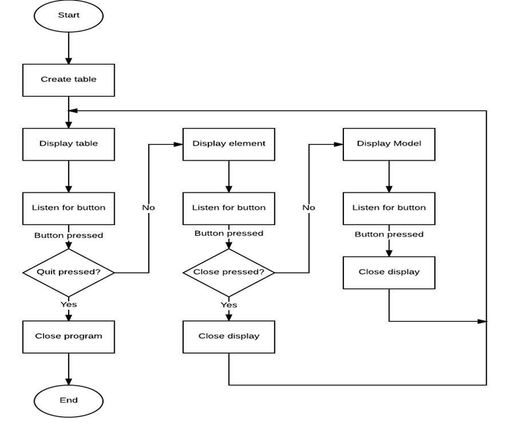

Appendix F: State Diagram
